***Java EE Web Site***

1. **The class diagram :**

Let’s see the class diagram:

There are three databases:

* *Personne* to describe students and teachers
  + Every person has a name
  + Every person is in a class, except teacher for who it is 0
  + Every person has a password to connect
* *Todo* is the database of the *Todo* with a name and a description
* *TodoClass* is an auxiliary class permitting to connect persons with todos.

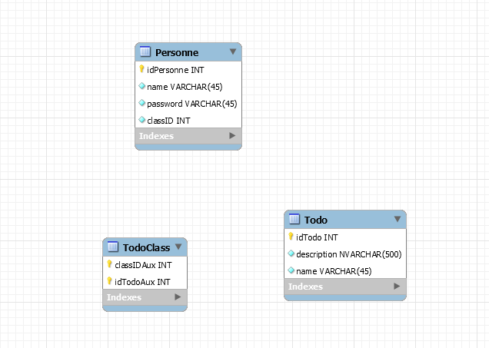

1. ***How it works :***

When you try to connect, the servlet sends a request to the database to try your *id/password* in *personne*.

If you are a teacher, you will be in the page where you can find all todos and you can also add one and edit or delete some todos in the list.

If you are a student, you will be in a page where you can find all todos which are link with you classID.

For every function which are looking in the database we create a class name todoDB, and in servlet each servlet in the Dopost we are asking todoDB’s function to find all argument and to print todos in the page.

We also create a Httpsession object when we start login in the first page. This session will have a classID of the person which has log, a name of the person and a list of todos link with this ID.

With this session in each page we can find every information about the person.

Finally the teacher in the page EditTodo and DelTodo we ask todoDB’s function to delete the todo from the sql database and the some for the edit.

1. ***Tips :***

You have to change the username/password in META.inf/context.xml to permit the servlet connecting to the database